**SPRINT 2**

|  |  |
| --- | --- |
| Date | 05 November 2022 |
| Team ID | PNT2022TMID16797 |
| Project Name | Project – Smart Farmer-IoT Enabled smart Farming Application |

# Sensor Connection

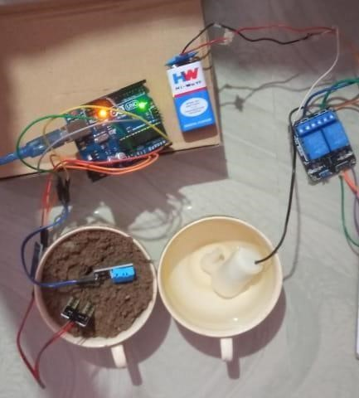

Device Details:

